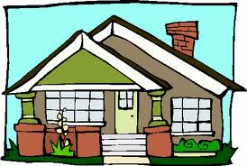
Request for Architectural
Committee Review

Chateau Woods Homeowners Association

NAME: | DATE:
ADDRESS: | LOT NUMBER:
EMAIL: | PHONE:

Provide a brief description of the proposed construction, additions or modifications to your home or property. Include a drawing showing work to be done, indicating dimensions. Provide paint samples as applicable. Use an attachment if necessary.

Forward to architecture committee for processing at CHATWOO@ciramail.com.

IMPORTANT DISCLAIMER: Homeowners Association approval is limited to aesthetic factors only and should not be construed as approval of any legal or technical considerations such as building codes, environmental statutes or the potential for personal injury, litigation or financial loss. Ultimate responsibility for all legal considerations and their consequences rests with the individual homeowner.

Architectural Committee Comments:
Jon Hedin

APPROVED | DISAPPROVED | CONDITIONAL APPROVAL

DISPOSITION BY: | DATE:

